**Adding a New Workstep (Templates Embedded):**

Please see below steps to add a new workstep with 2022 updates included. 2022 audits active prior to 3/31/22 should follow these steps to ensure most accurate worksteps/templates.

The following new worksteps were impacted by updates and should be manually added:

* Scope Document *(alternatively, users may add the new Proposed Areas of Focus field into existing workstep and template, rather than create a new one)*
* Preparation and Review of Kick-Off Deck
* Director and CAE Review of Kick-Off Deck
* Kick-Off Deck Distribution *(Houses Kick-Off Deck draft, similar to Audit Report Distribution workstep)*
* Director and CAE Report Review
* Audit Report Distribution

1. Click Configuration to go to Project Configuration screen

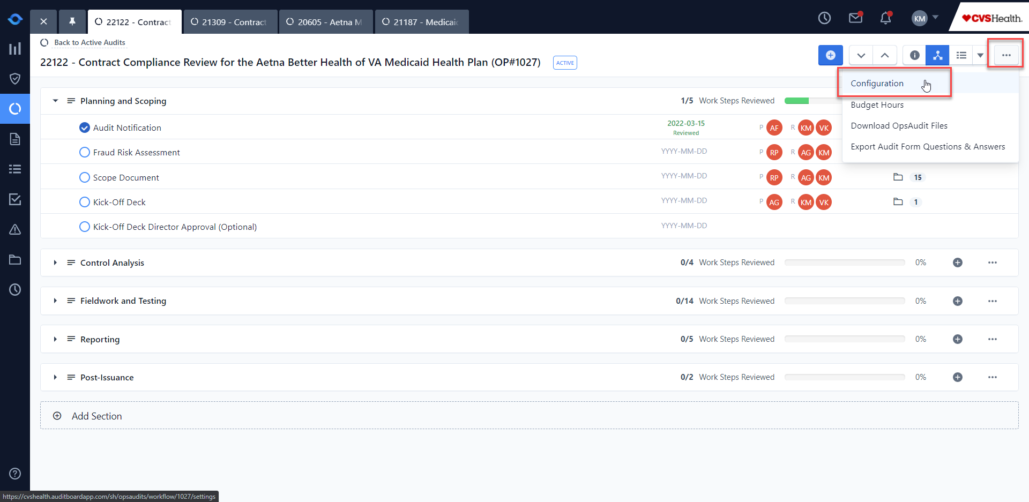

1. User must be assigned as Project Administrator

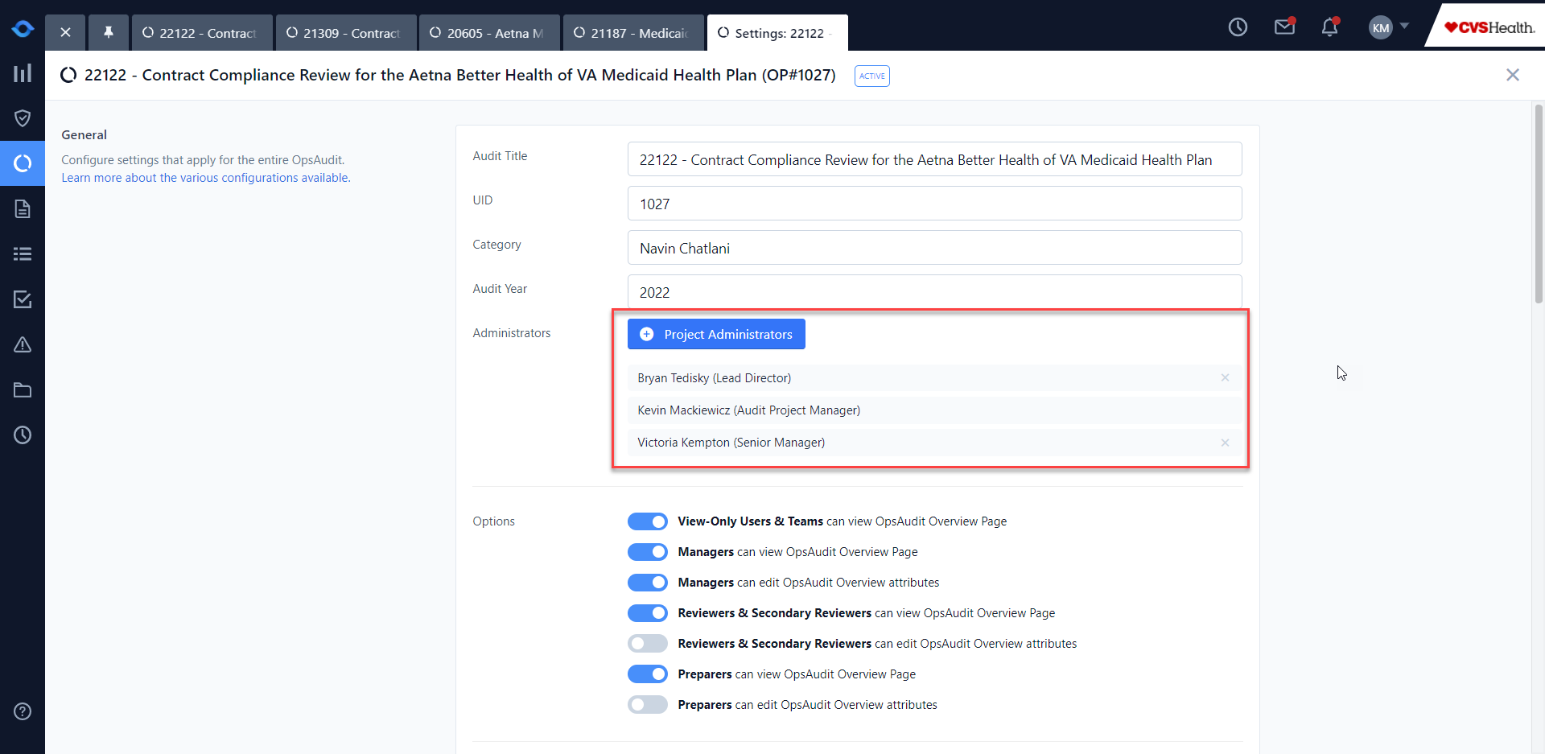

1. User must be assigned Manager role.

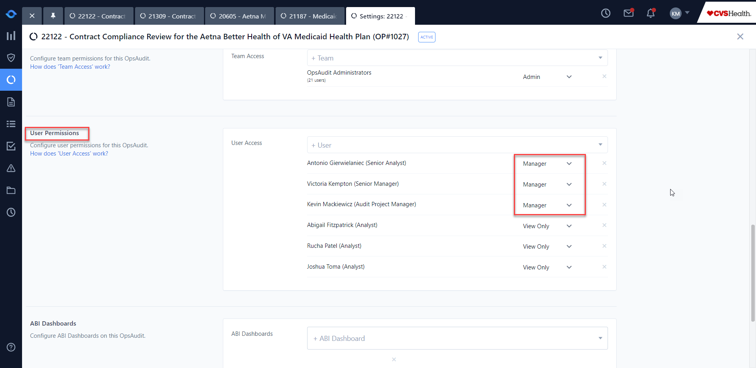

1. Select blue (+) sign and Import Work Steps from Template

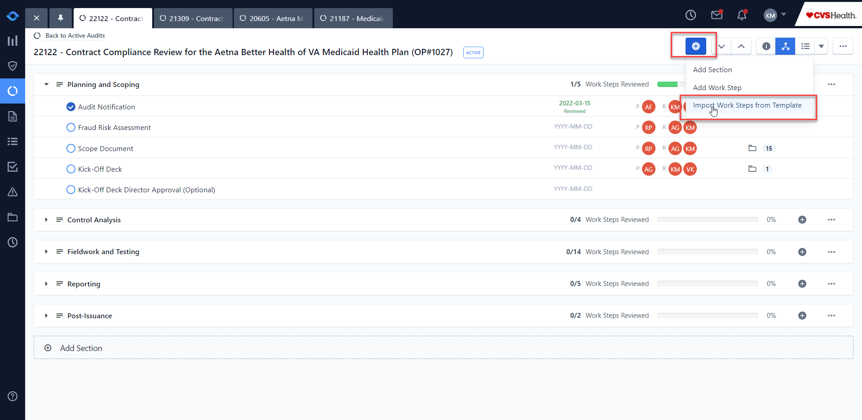

1. Select Audit Template, audit phase, and applicable worksteps.

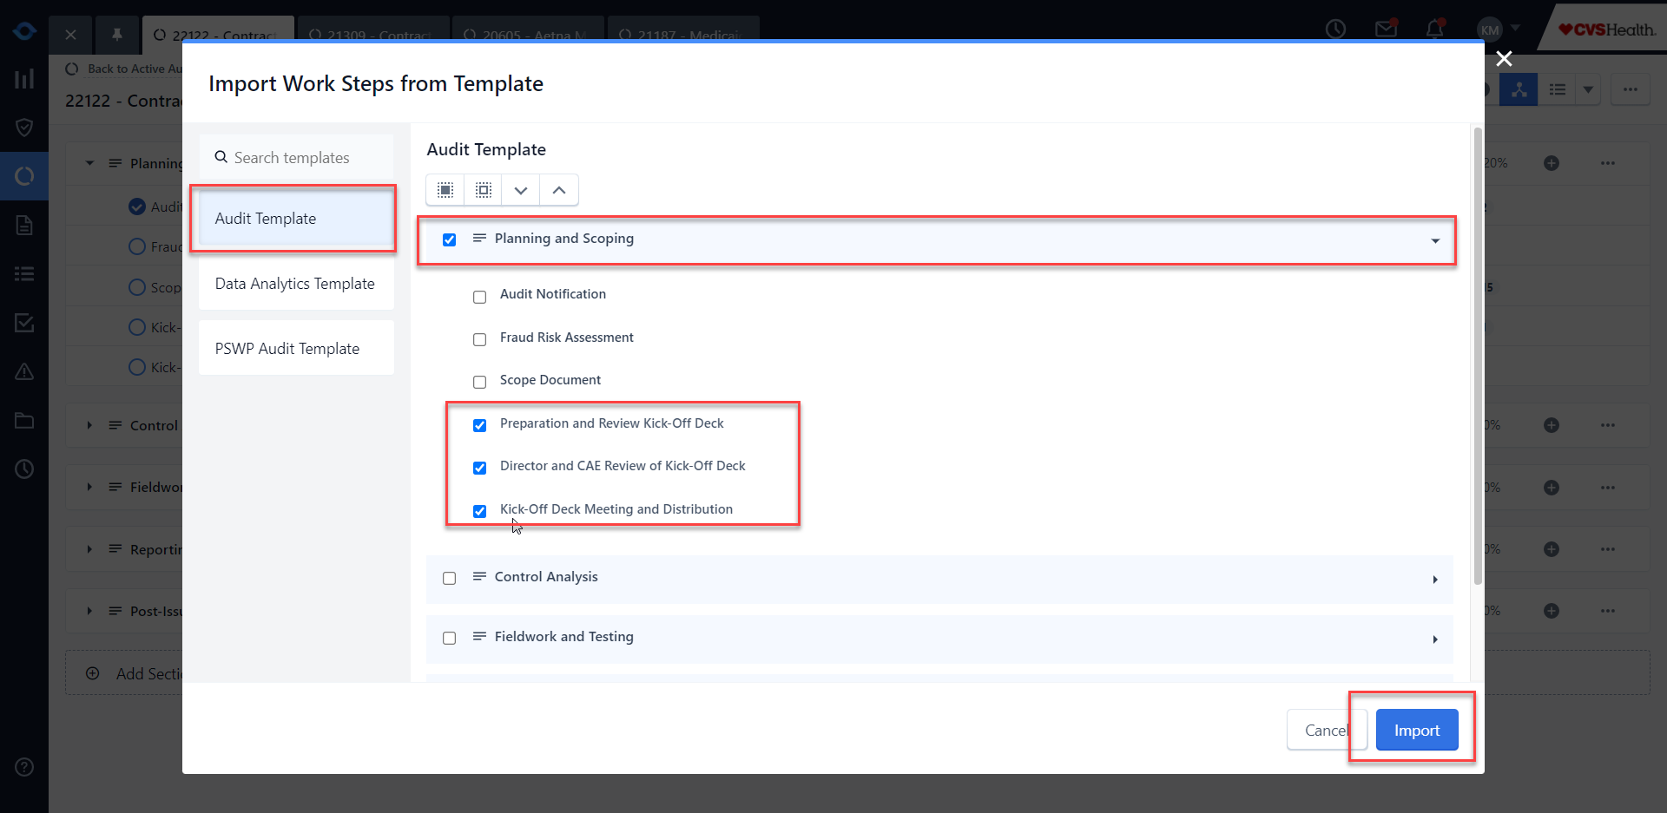

1. Delete any old worksteps per usual process. NOTE: Please carry over any existing work from the old worksteps.

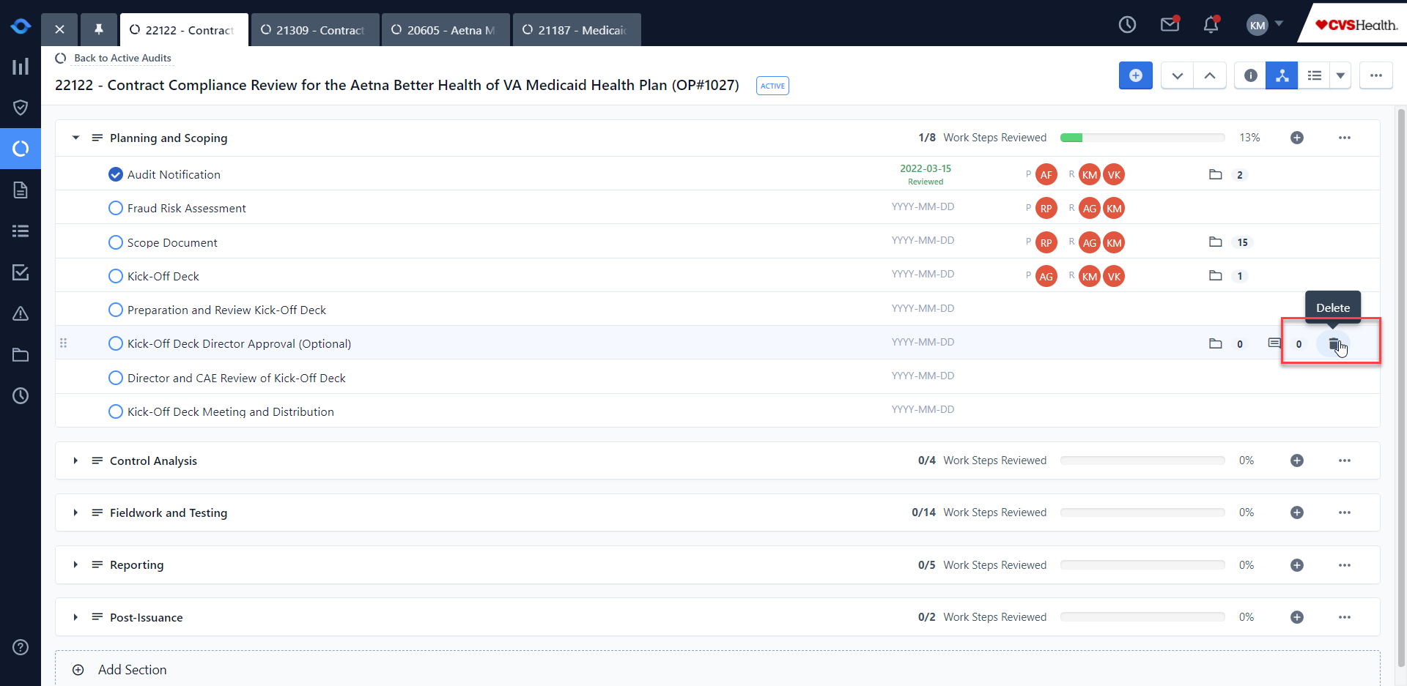

**Adding a New Template (document):**

To add a new template, users may follow the usual process of accessing Resource Files in AuditBoard. Templates impacted by updates include:

* Scope Document *(note – this template is embedded within the workstep. Please see above for instructions on adding new workstep)*
* Kick-Off Deck
* Audit Report Distribution email to CAE

